Memorandum B

To: Daniel Rodríguez Román, PhD

From: Gabriela Alicea 802-18-6099, Natalia Fernández 802-18-9320

Date: December 6, 2019

Subject: Final Report - Rock, Paper, Scissors

Our fun game of Rock, Paper, Scissors made from Python has the objective of entertaining the user. It does so by making the user compete against the computer in the classic game of “Rock, Paper, Scissors” where each player randomly selects which item to use and from there determine winners. Scissors beat paper, rock beats scissors, and paper beats rock. Therefore, the possible outcomes of this game are uniquely restricted to winning, losing or having a draw. The user selects and item and once the computer chooses an item, it determines who wins, it notifies the user and then appends the game information to a list in which the game history is being tracked.

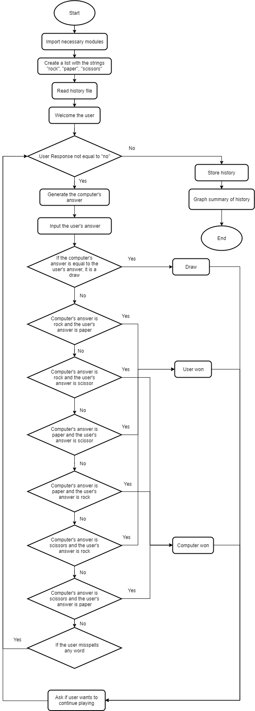

Program inputs involved in this game are a sequence of the user’s option to play either “rock”, “paper”, or “scissors” followed by an option asking if they wish to play another game. When the user enters any playing option, the computer randomly selects its own option which is then compared to the user’s input to determine the winner. This user input can contain any combination of upper and lower-case letters inside, as the game takes care of making this input lowercase. When the game later asks if the user wishes to play another game, if the user enters “no” it will stop accepting user input and will follow through with the program. Otherwise, if the user enters any other character(s) it will continue to another game

Another input this program takes is a file called “history.csv” located In the same directory as the script. Even though it Is initially optional, having such a file records the history of past games and enables viewing these games’ results afterwards.

Program outputs involved in this game are a csv file containing game history and a total of three plots. The csv files that contains the game history is automatically called “history.csv” and it is updated once the user decides to not keep playing. It includes the user input, computer’s move and the result for each of the game entries it contains. If “history.csv” already existed, this output practically appends new data to the original file.

The three graphs that are outputted from the game are two bar plots representing frequency tables and a history of wins, losses and draws. The first graph shows the user’s frequency of using either “rock”, “paper”, or “scissors” and the second includes this same data, but for the random computer choices. The last graph, which includes a history of wins, losses and draws, is represented as a bar graph with one colored bar representing each state: a green bar representing a “Win”, a blue bar representing a “Draw”, and a red bar representing a “Lose”.